

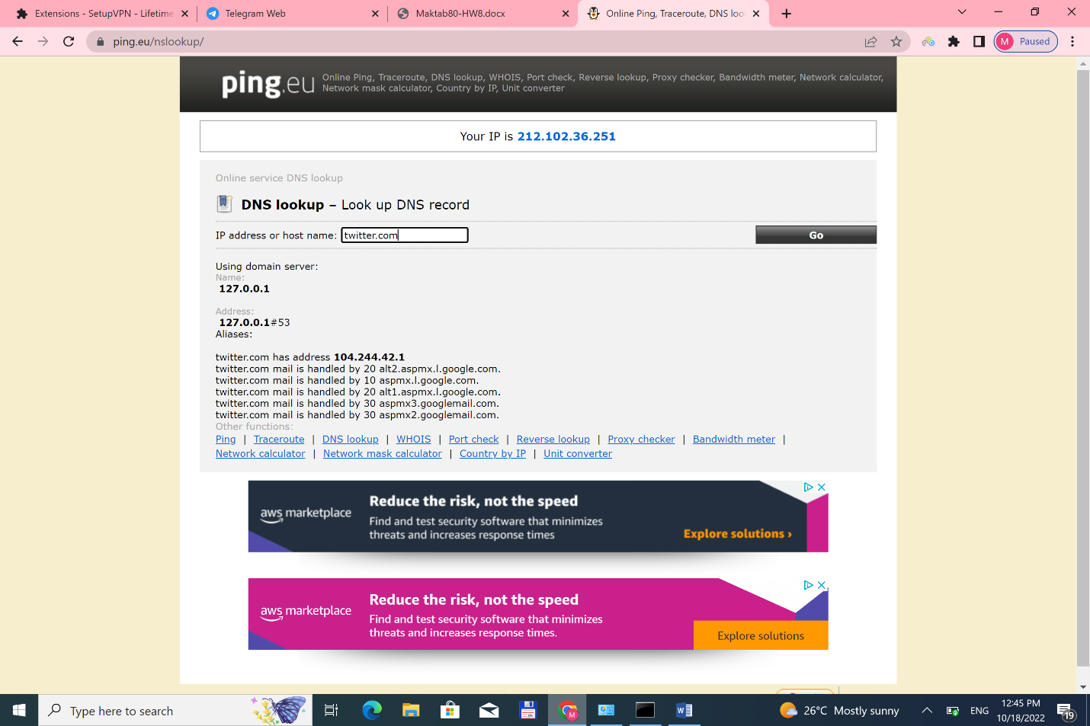

The reason that nslookup can operate differently to ping when it comes to converting domain names to IP addresses is that **ping uses the system-supplied library, as used by other applications, for name-to-address mapping whereas nslookup has its own, built in, DNS client library**.

